**Ideation Phase**

**Brainstorm & Idea Prioritization Template**

|  |  |
| --- | --- |
| Date | 15 March 2023 |
| Team ID | NM2023TMID16367 |
| Project Name | Flight delay prediction for aviation industry using machine learning |
| Maximum Marks | 5 Marks |

**Brainstorm & Idea Prioritization Template:**

During this activity, our team members gathered and disguised various ideas to solve our projects. Each member contributed six to ten ideas. After gathering all ideas, we assessed the impacts and feasibility of each point.

Finally, we have assigned priority for each point based on these impact values.

**Step 1 Team Gathering, Collaboration and Select the Problem Statement**

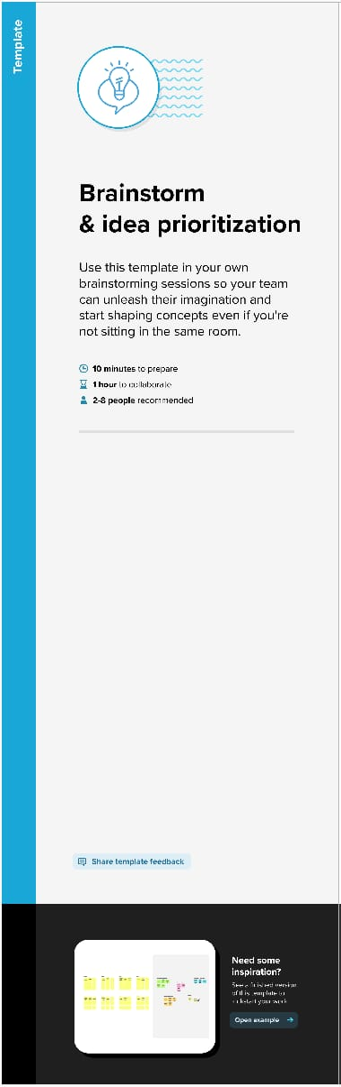



**T**

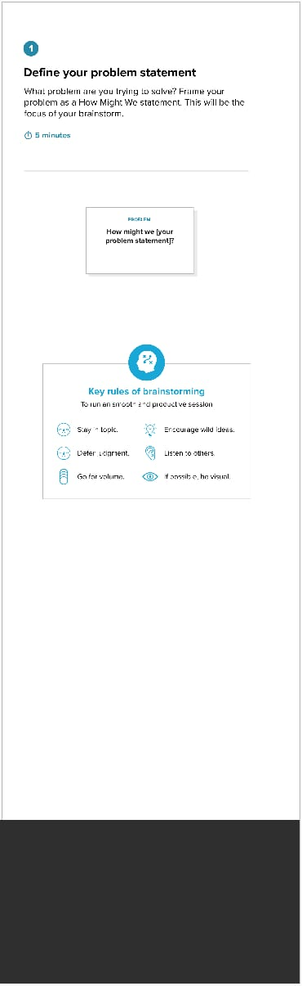

**Step 2 Brain Storm, Idea Listing and Grouping**

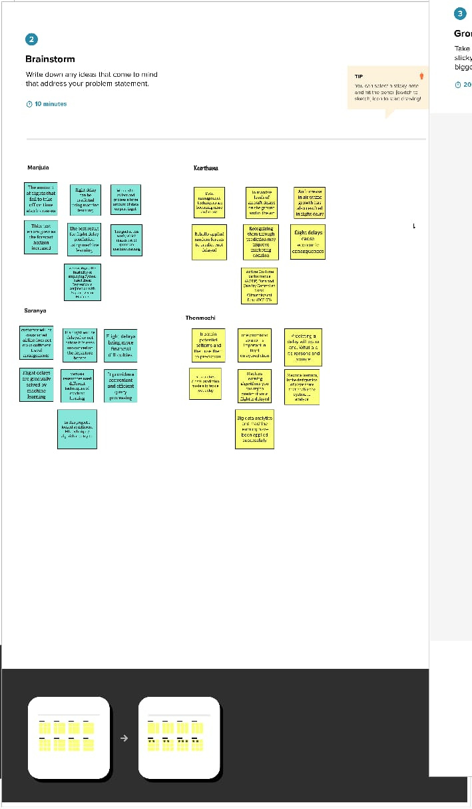

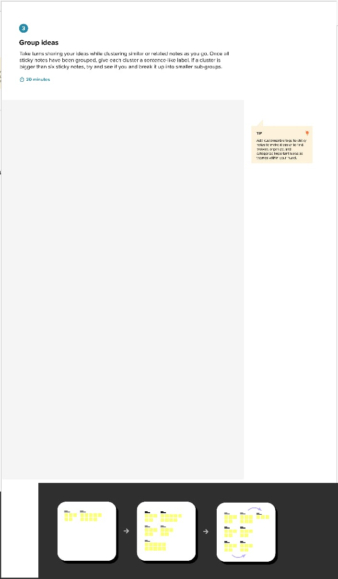

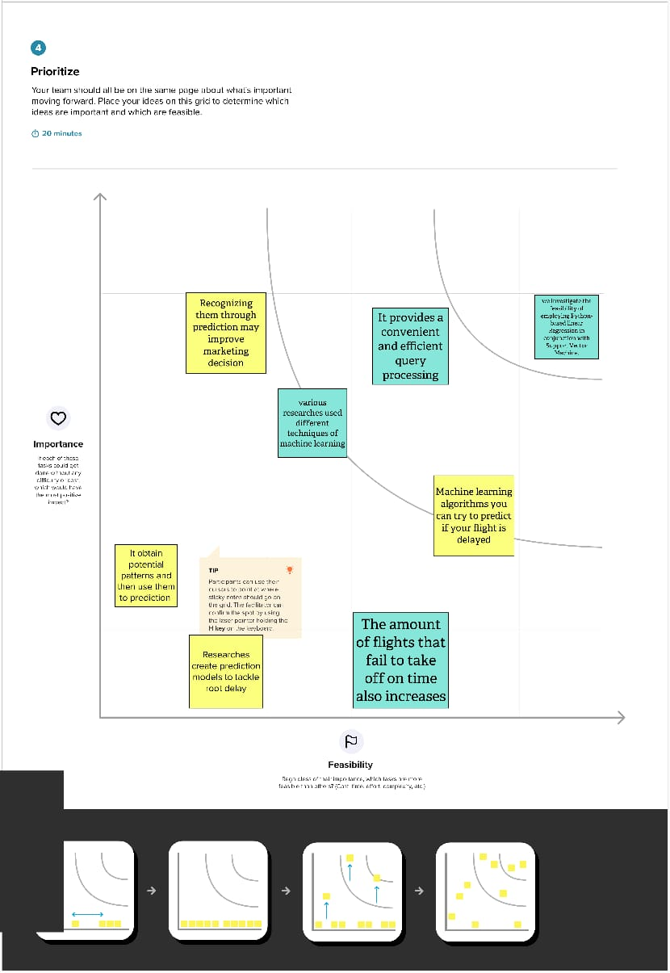



**Step 3 Idea Prioritization**